**RELABELING.IPYNB**

[Errno 21] No such file or directory: /content/drive/MyDrive/Verizon ML Project/Verizon Phone Cases Spreadsheet.xlsx

The following error means that there is no known directory under this name in your drive, which the script uses in order to pull the data as Colab relies on Drive to edit and modify files and keep them after the session is over.

In order to fix it, you will have to add the project folder shortcut to your Google Drive:

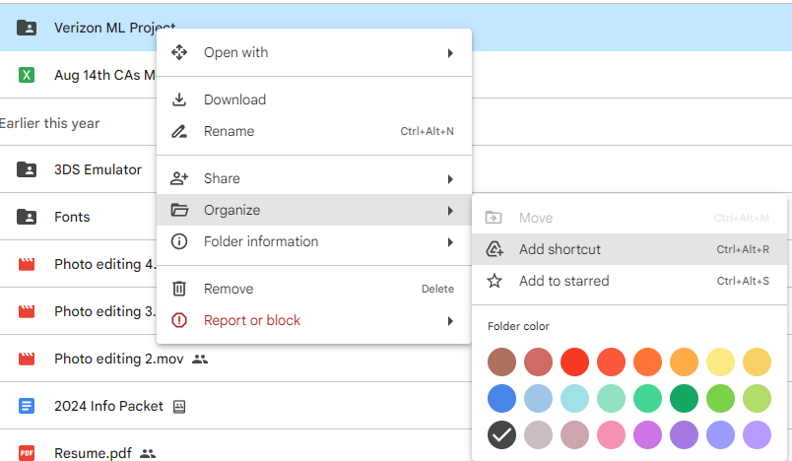

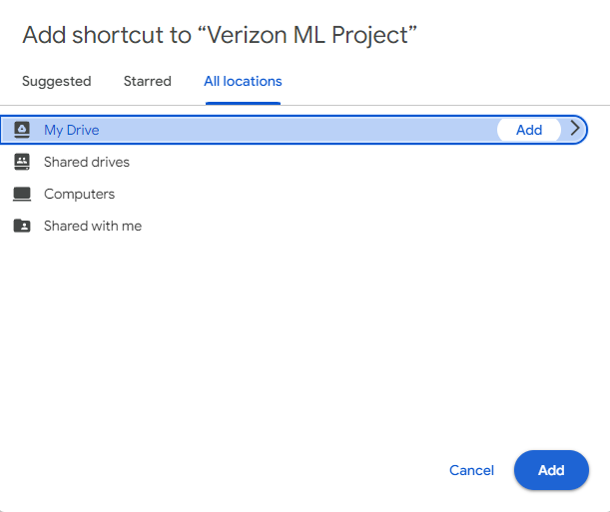

After following these steps, the script should run as intended.